Project Design Phase-II

Data Flow Diagram & User Stories

Date | 01 November 2025
Team ID | NM2025TMID00449
Project Name | Laptop Request Catalog Item
Maximum Marks | 4 Marks

Data Flow Diagrams :

Data Flow Diagram (DFD) Description
A Data Flow Diagram visually represents how information flows through your ServiceNow laptop request system. The DFD shows how an employee submits a request, how the ServiceNow catalog item processes the data, how dynamic UI policies validate and guide form filling, and how the IT team receives and fulfills the request.
DFD Components for Your Project:
- External Entities: Employee, IT Admin
- Processes: Submit request, Validate dynamic fields, Log request, Approve/Reject request
- Data Stores: Request records, asset inventory, update set logs
- Flow: Employee fills catalog item → System guides user via dynamic policies → Data validated → Request logged for IT → IT acts on approval/fulfillment
Example:
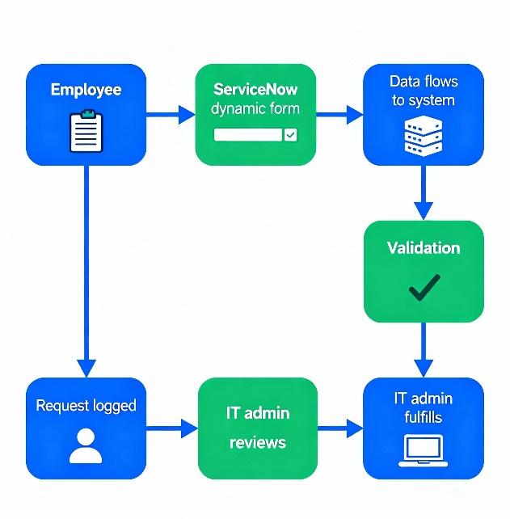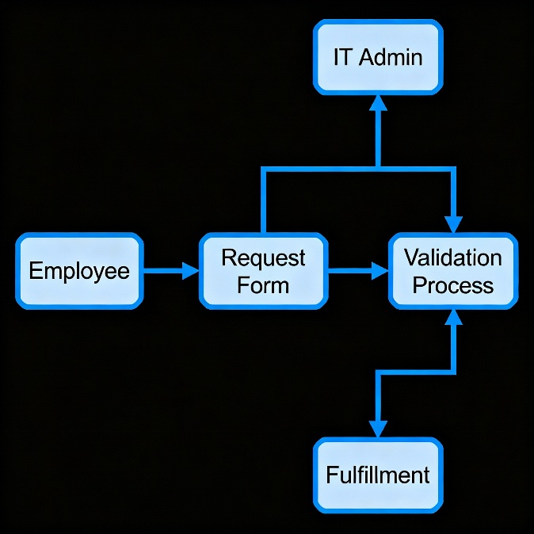
Sample User Stories :

User Story Number | As a... | I want to... | So that...
USN-1 | Employee | Easily request a laptop from a digital catalog | I can start my work quickly and error-free
USN-2 | Employee | Only see fields relevant to my request in the form | I don’t get confused or miss any details
USN-3 | IT Admin | Receive complete, validated requests | I can process requests faster with fewer follow-ups
USN-4 | IT Admin | Track all changes and requests | I maintain proper records for asset management and audits

DFD Example (Textual Description)

- Employee accesses the Service Catalog.
- System presents the Laptop Request catalog item.
- Dynamic UI policies show/hide fields as needed.
- Employee submits the request.
- System validates and logs the request.
- IT Admin reviews, approves, and fulfills the request.
- Data updates in request records and asset invent.

